Hospitality and Tourism

Professional Selling Presentation

Mr. Bodenburg

**THE SITUATION IV**

You will assume the role of director of sponsorships for a local event taking place within your community. You are meeting with a local business that has interest in becoming a sponsor of the event. In the meeting, you should explain the sponsorship program, various sponsorship packages available and recommend the sponsorship level appropriate to the business.

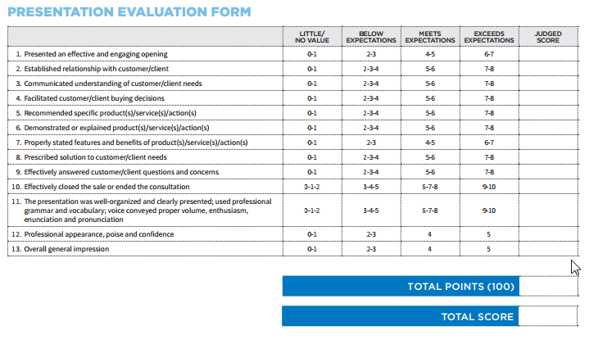

**YOUR ROLE**

* Tout the marketing opportunities that are available at his event
  + Describe the sponsorship program
  + Give specifics about the levels of sponsorship
  + Recommend a sponsorship package to the local business
* The goal is to get a contract signed with the local business for the local event